Week 7
Lab 2: SQL

- The people who have written and sung a particular song and whose name is begin with ‘D’.
  - 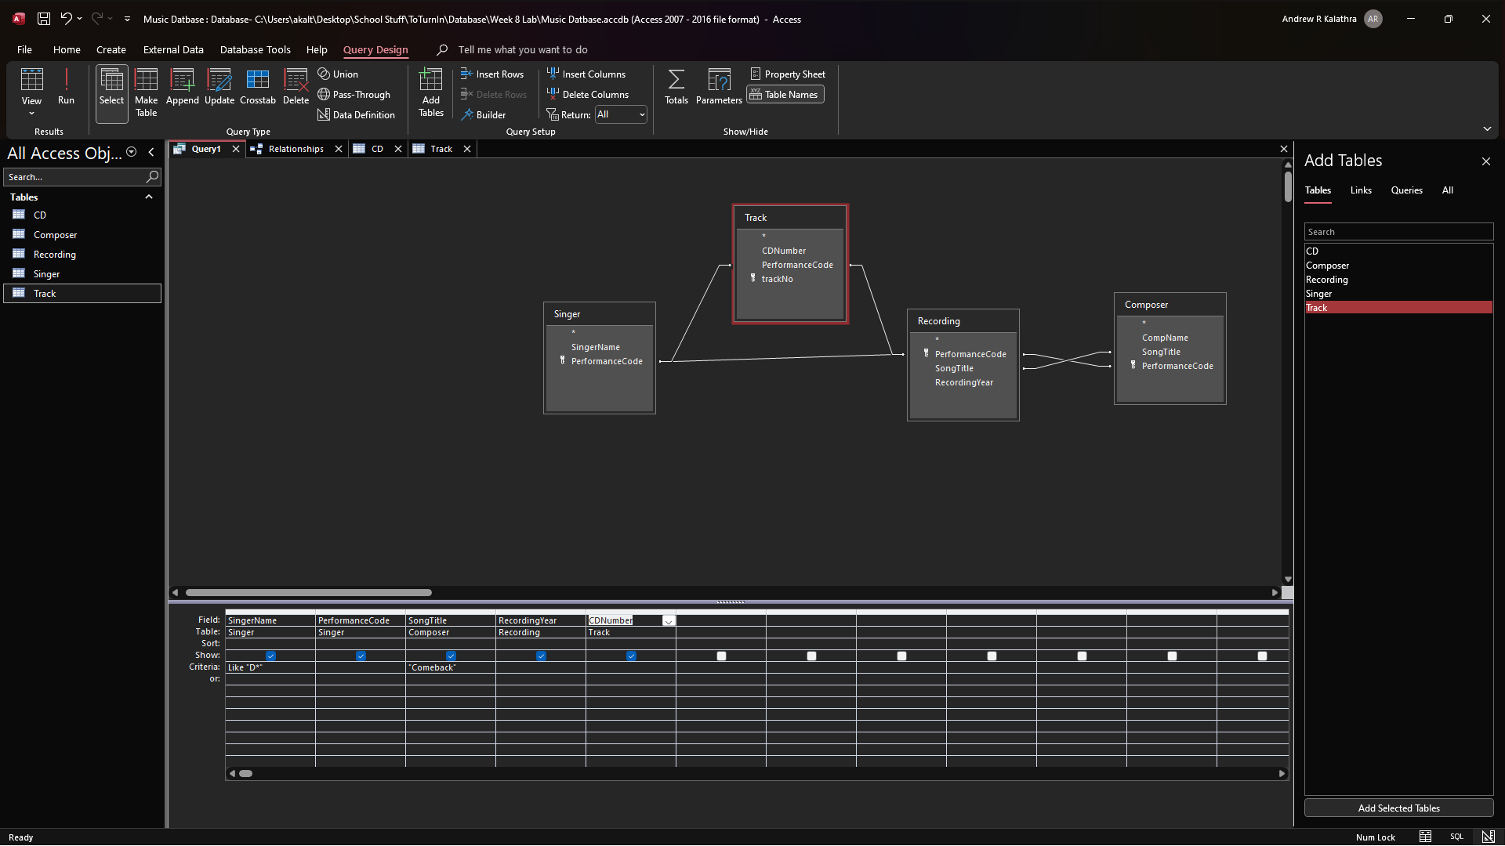
  - 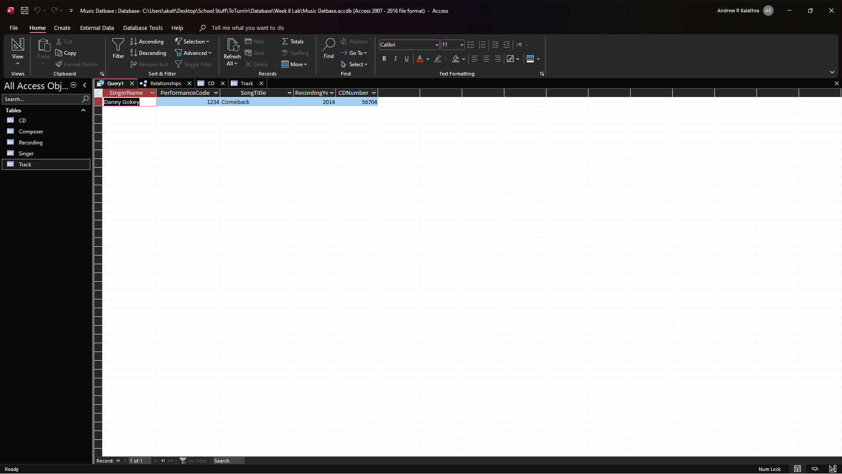
- The titles of the CDs that contain songs of which the year of recording is not known.
  - 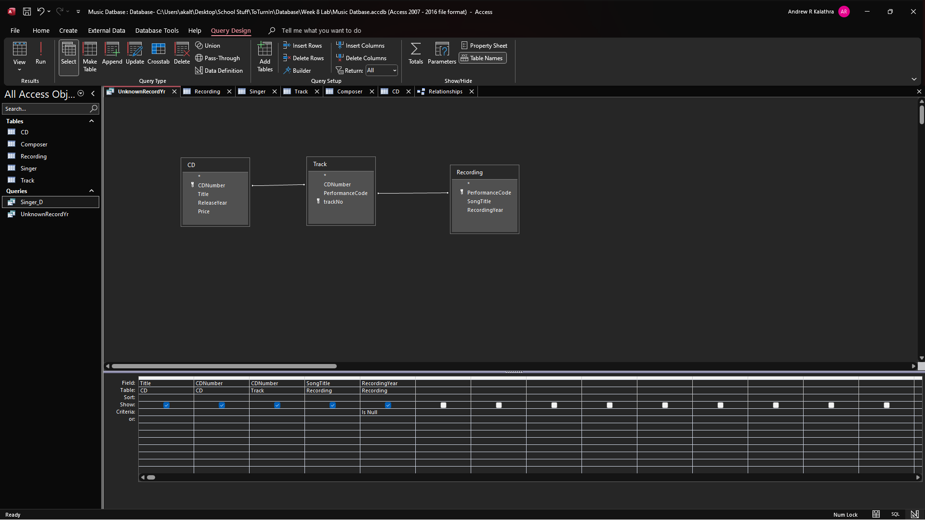
  - 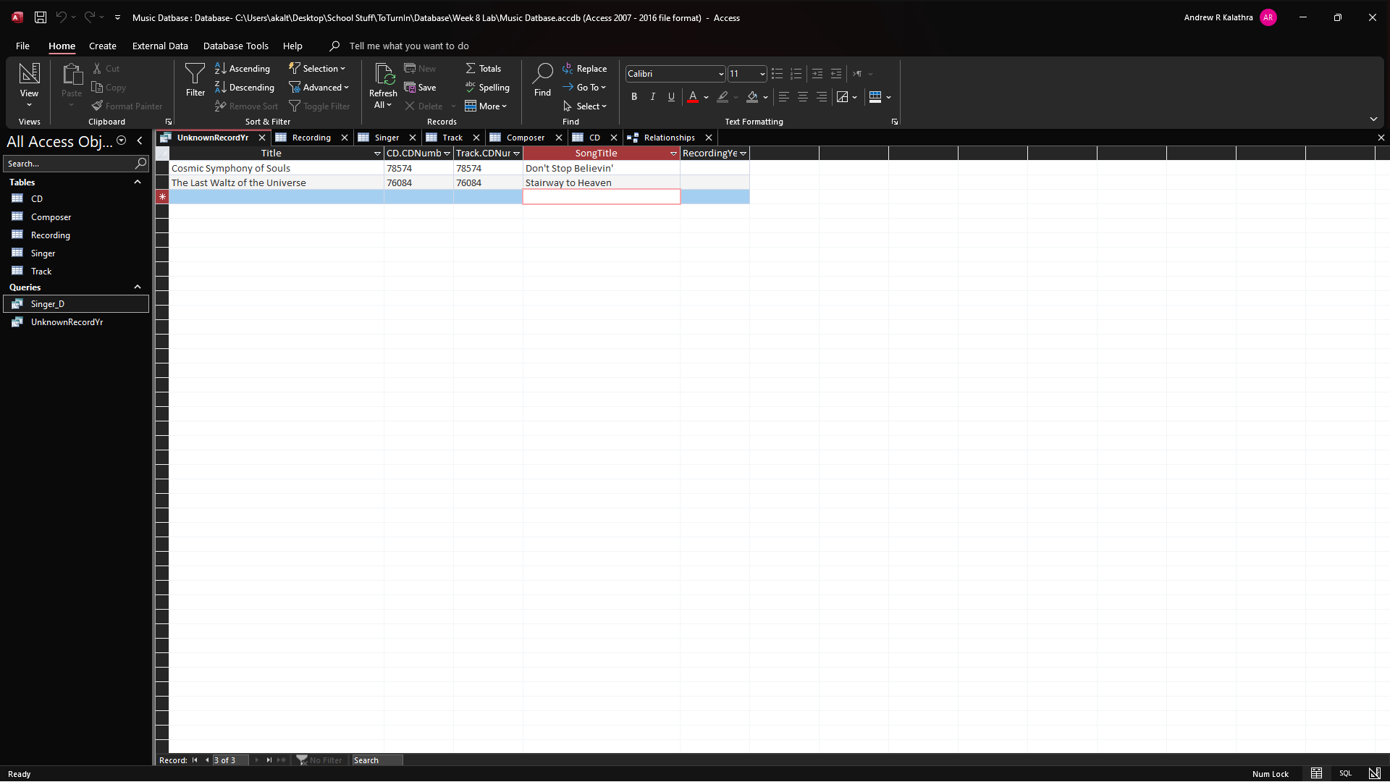
- The tracks on the CDs with the serial number 78574. Provide these in numerical order, indicating the performers for the track having a singer
  - 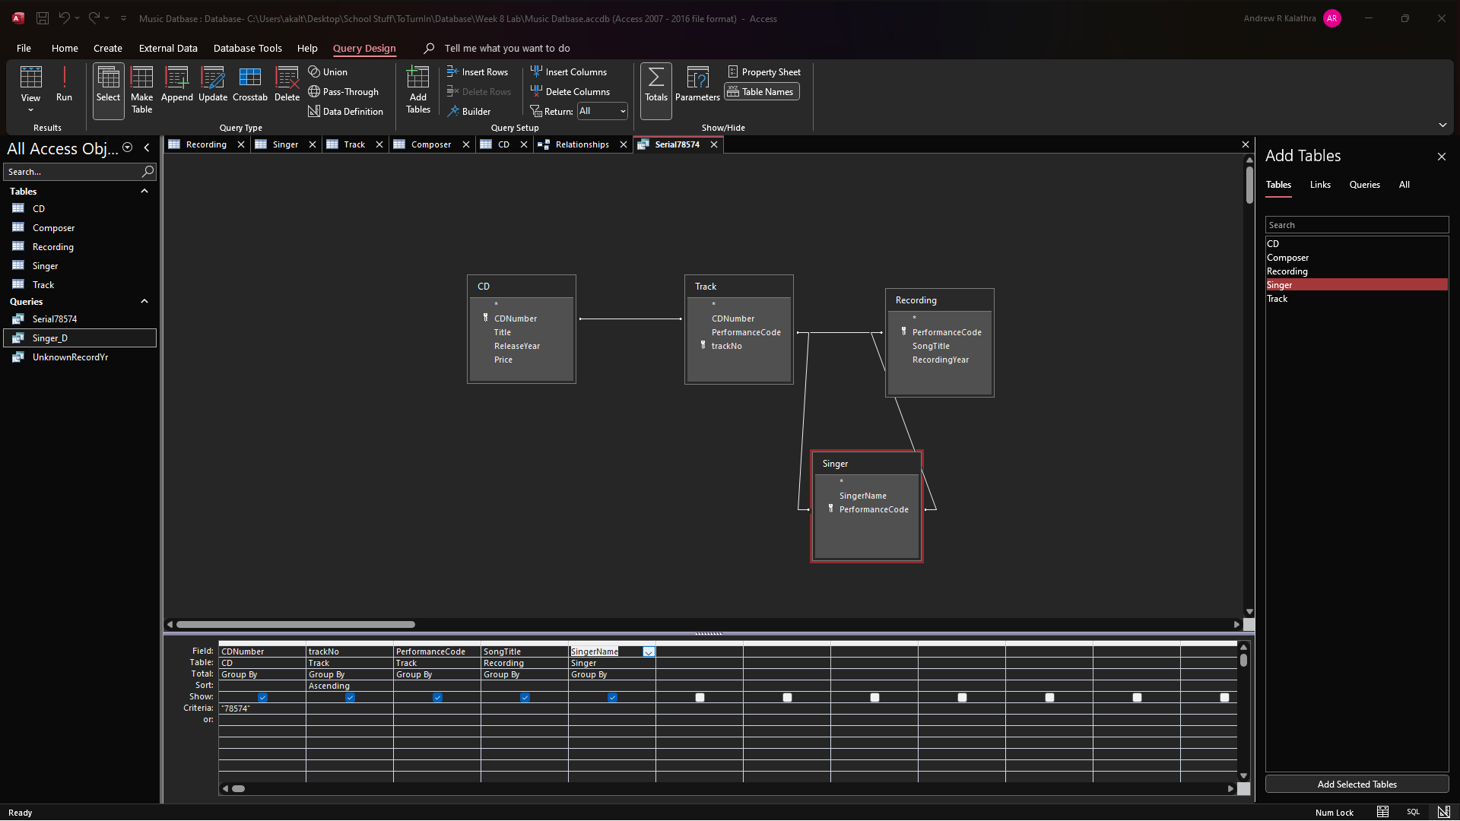
  - 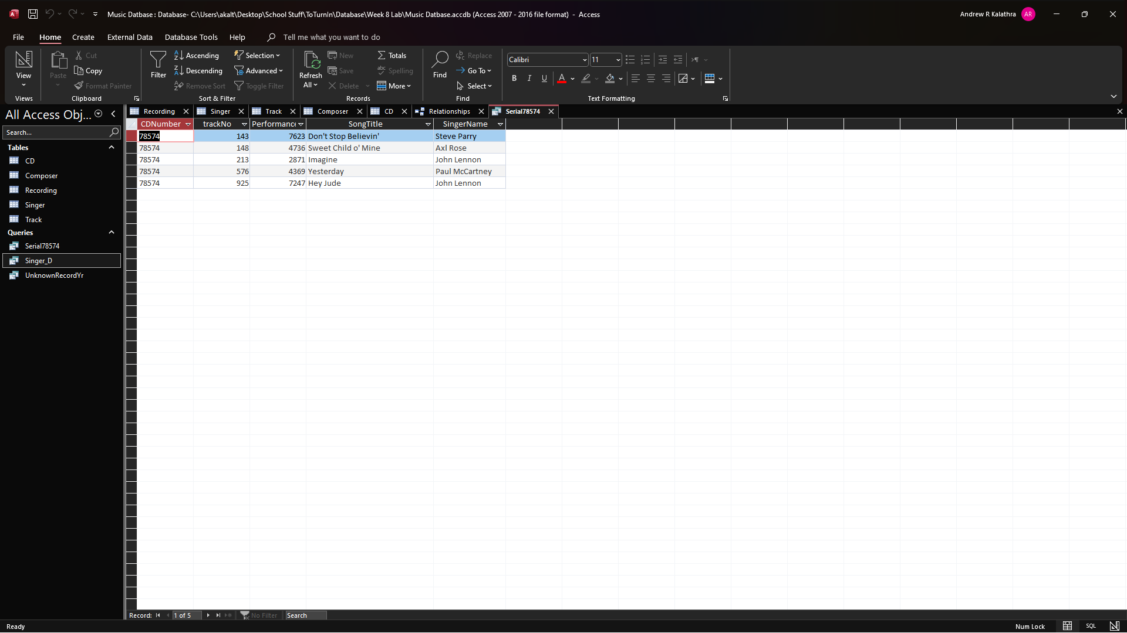
  - As they are all the same CDNumber (serial number), they are ordered in ascending order by trackNo. All the songs also happened to have an associated singer.
- The exclusive composers and singers. That is, composers who have never recorded a song and singers who have never written a song.
  - 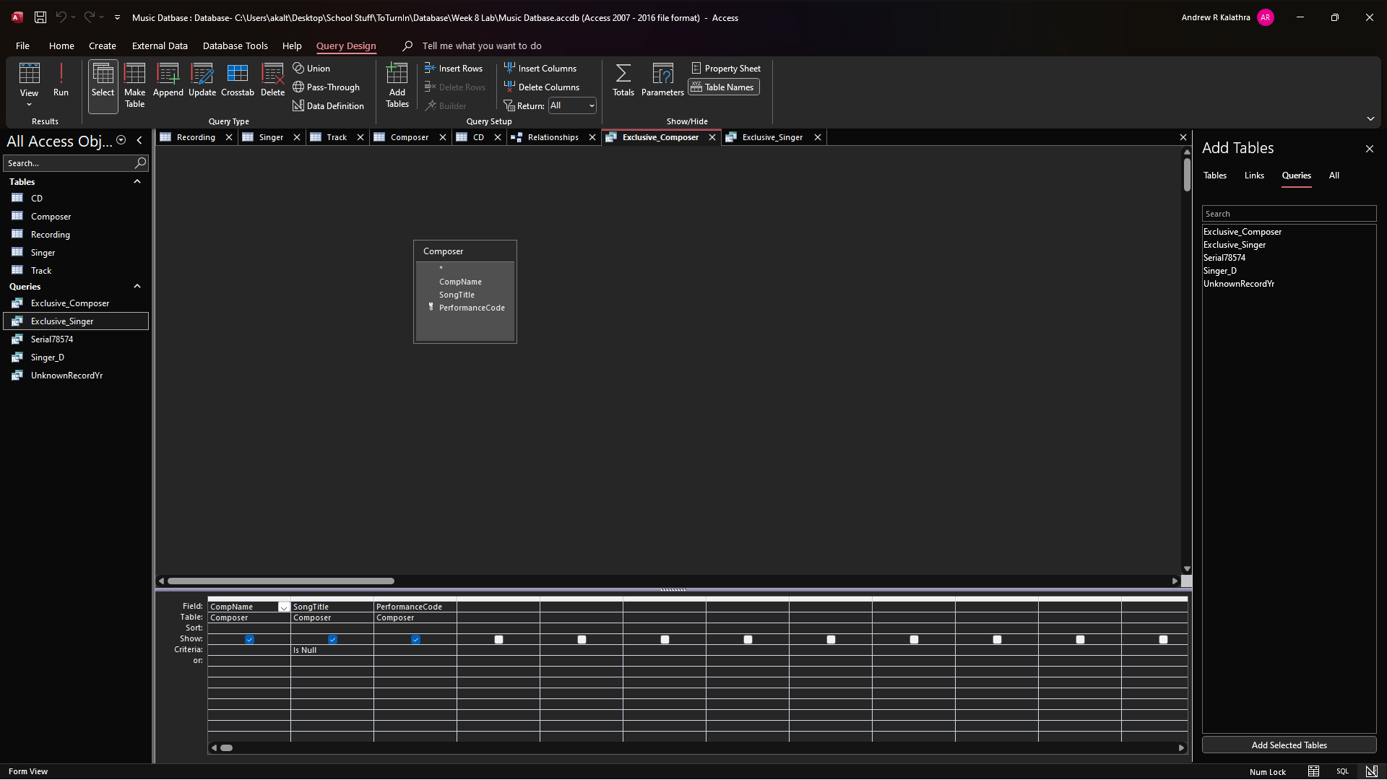
  - 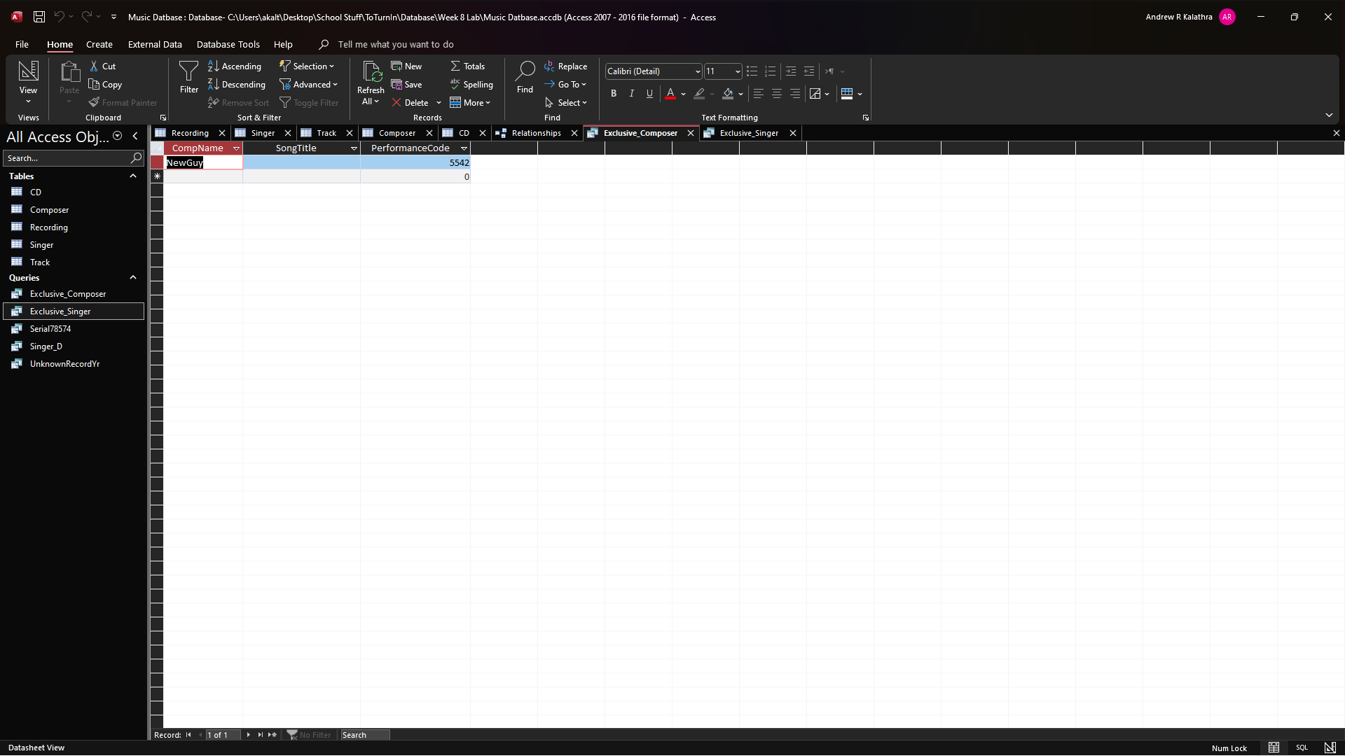
  - 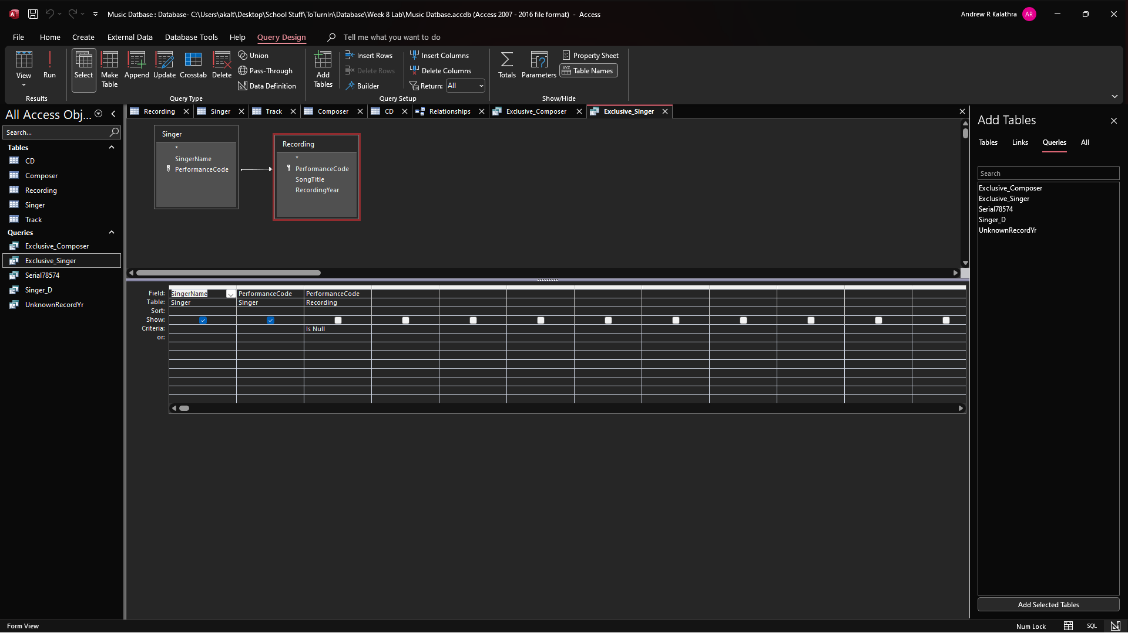
  - 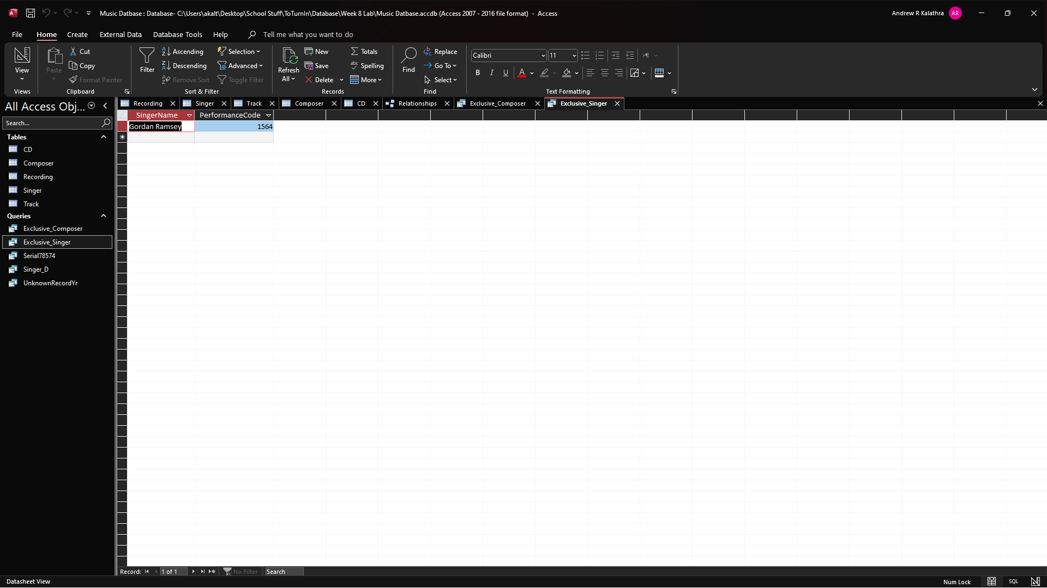
  - The queries cannot be combined due to the different attribute titles and different fields involved.
- The singer on the CD that contains the largest number of songs
  - 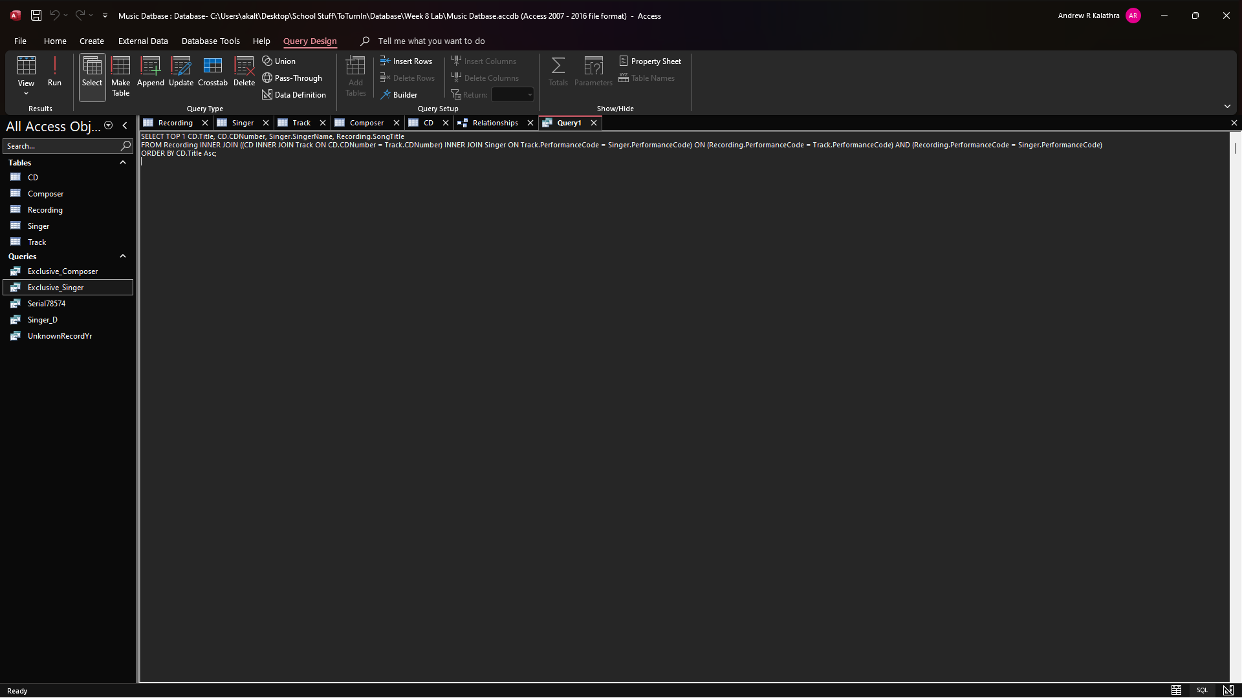
  - 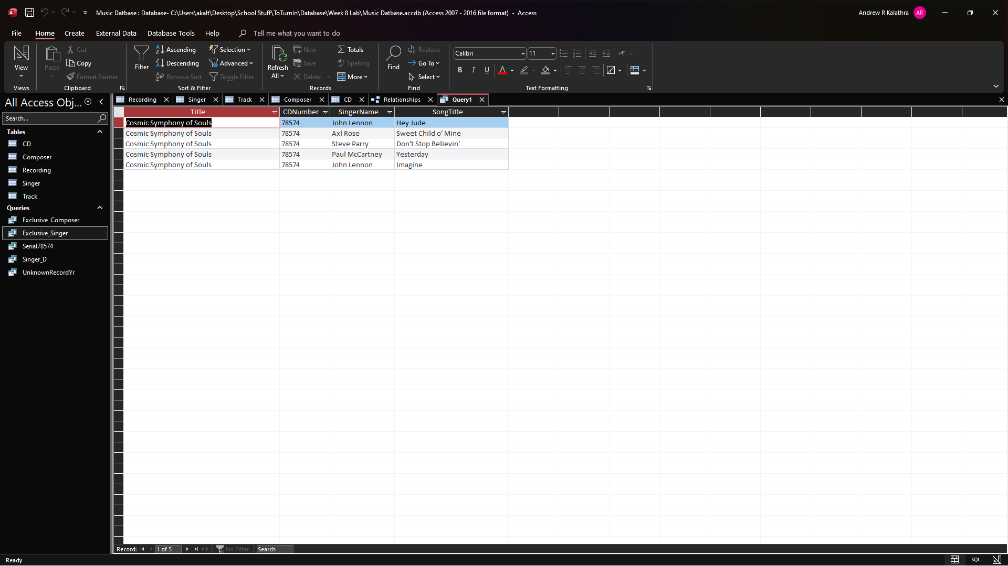
  - I guess it was a collaborative effort by The Beatles and others.

